BUS Detail Design

DOC. No.: | REV.: 01 |  |  | PRODUCT:
TITLE: BUS Detail Design |  |  |  | Project:
Prepared by: | Van Zhong |  |  | Date:
Remark: | Approval:
Remark: |  | Department | Title |  |  | Signature
Remark: | 1 | Electronic R&D
Remark: | 2
Remark: | 3
Remark: | 4

Revision | Description of Change | Author | Date
00 | BO interface base BOS. | Van Zhong | 10/23/2009
01 | BO interface and implement base EVA6.1. | Van Zhong | 07/21/2010

1. Overview 4
1.1. Objective 4
1.2. Scope 4
1.3. Reference 4
1.4. Abbreviations 4
2. Design Concept 4
3. Interface Design 4
4. BOS 7
4.1. BOS Class Diagram 7
4.2. Class Introduction 8
4.2.1. BOS mutation file (configuration file) 8
4.2.2. BOS opn file (turnover file) 8
4.2.3. BOSAdm 9
4.3. BOS COM30 slaver 9
4.3.1. Thread design 9
4.3.2. COM30 Class Introduction 9
1.1.1.1. CBosFilePathMgr 9
1.1.1.2. BosCOM30Adaptor 9
1.1.1.3. COM30CtxMgr, ICOM30Ctx, COM30Port 9
1.1.1.4. CSlaveSession, COpnSlaveSession, CMutSlaveSession, CSlaveSessionMgr 9
1.1.1.5. com30, COM30Bus 9
1.1.1.6. BosCOM30TaskImp 9
4.3.3. Unit Test 9
4.4. COM30 Thread Model 10
4.5. BOS error code define 10
5. EVA 11
5.1. EVA Database Detail Design 11
5.2. EVA Class Diagram 12
5.3. Class Introduction 13
5.3.1. EVAAdm 13
5.3.2. EvaVendHelper 13
5.3.3. EvaDB 13
5.3.4. EvaConfigMgr 13
5.3.5. EvaToolFunc, EvaVendFunc, EvaCoinFunc, EvaBillFunc, EvaSpecialFunc, EvaTokenFunc 13
5.4. EVA DDCMP slaver 13
5.4.1. Thread design 13
5.4.2. DDCMP Class Introduction 14
1.1.1.7. EvaDDCMPAdaptor 14
1.1.1.8. DDCMPCtxMgr,IDDCMPCtx,DDCMPPort,DDCMPIrDA 14
1.1.1.9. DDCMPBus 14
1.1.1.10. EvaDDCMPTaskImp 14
1.1.1.11. EvaInterface 14
1.1.1.12. EvaParser 14
1.1.1.13. EvaParserList1 14
1.1.1.14. EvaParserList64 14
5.4.3. Unit Test 14
5.5. DDCMP Thread Model 15
5.6. EVA error code define 15

Overview

Objective
The back office module MUST base on EVA6.1. The EVA6.1 introduces “discount” and “surcharge” concepts while using card. The PA7 data element must be implemented in EVA6.1. Our objective is that our back office module’s interfaces are based on EVA6.1, and database design in EVA can be implemented successfully to support PA7. Also, BOS can implement all these interfaces.

Scope

This document describes the design issues of back office module. Now it is including EVA and BOS. The back office module’s interfaces are based on EVA6.1,
NOT based on BOS.

Reference

1. SL15 SW HLD.doc.
2. docs\Detail design\classDiagram.uml for detail class diagram.
3. docs\Database design\eva.vsd for database design in EVA.
4. EVADTS_6-1.pdf
5. BOS System description.DOC
6. EVA BOS Overview 081207.ppt
7. EVA-BOS Comparison.doc

Abbreviations
BO: Back Office
BOS: Back Office System
EVA: European Vending Association

Design Concept

- Same interface, different implement.
- Interfaces and implements are based on EVA6.1. In BOS, it has its own implements according by EVA interface.
- Loose coupling, easy testing. Each class and interface can be tested in unit test.
- Easily extend.

Interface Design

Back office module is designed based on interface. It has the same interfaces which in “interface base class” IAdm.
However, BOS has its specific interfaces with others having none. And EVA also has its specific interfaces too.
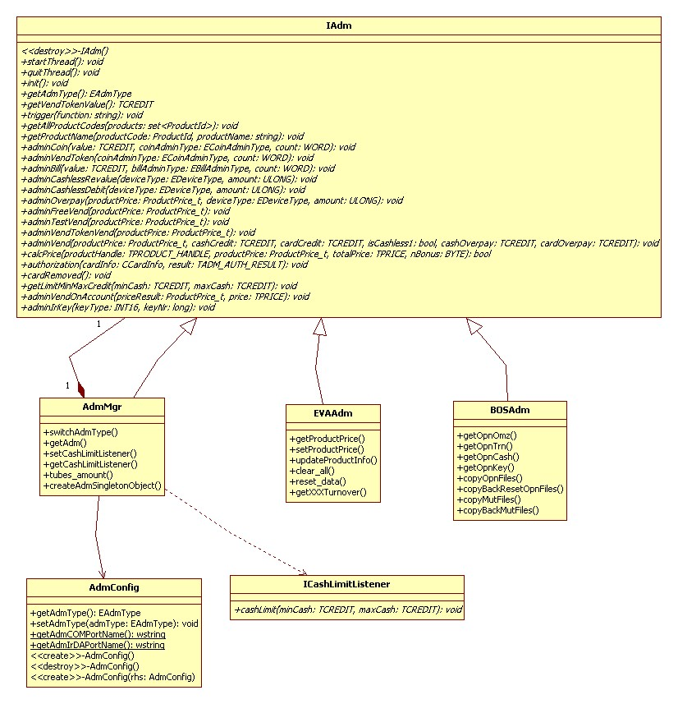

IAdm is common interface for back office modules.
BOSAdm and EVAAdm are derived from IAdm, they also have own specific interfaces.
AdmMgr kept an IAdm pointer (which is point to BOSAdm or EVAAdm), it implements all IAdm interface by this IAdm derived class pointer.
AdmConfig get/set some BO module parameters, such as: current back office type, COM port name, IrDA Port name… Some parameters must be persistent.

The following table listed all the interfaces.

Common interface function in IAdm | BOS specific interface function | EVA specific interface function
Init
getAdmType
getVendTokenValue
Trigger
getAllProductCodes
getProductName
adminCoin
adminVendToken
adminBill
adminCashlessRevalue
adminOverpay
adminFreeVend
adminTestVend
adminVendTokenVend
adminVend
calcPrice

authorization
cardRemoved
getLimitMinMaxCredit
startThread
quitThread
 | adminVendOnAccount
 | adminIrKey
 |  | adminCashlessDebit
 |  | getProductPrice
 |  | setProductPrice
 |  | updateProductInfo
 |  | clear_all
 |  | reset_data

BOS

BOS Class Diagram
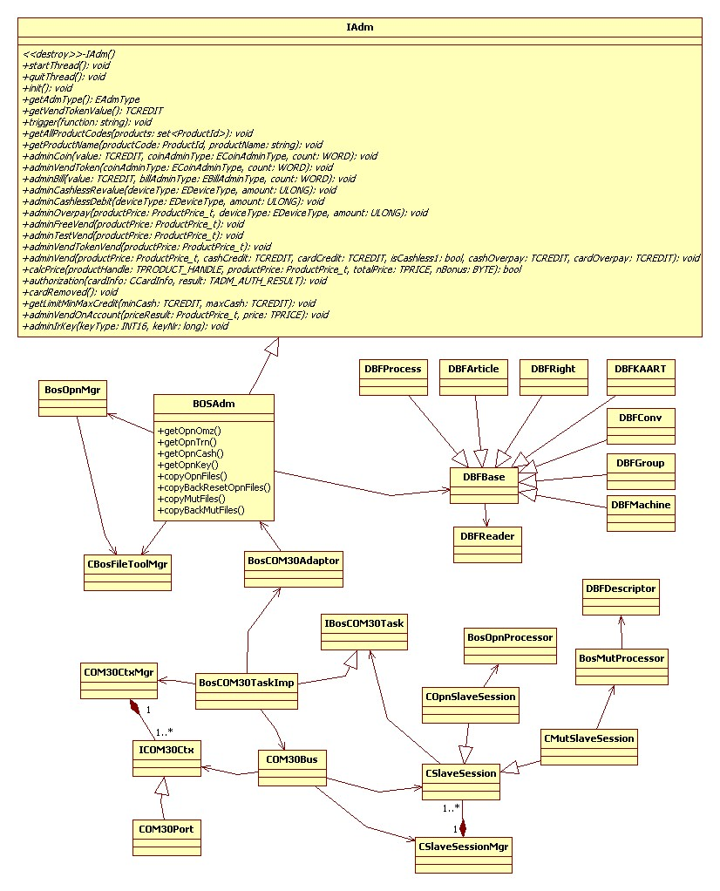

Class Introduction

BOS mutation file (configuration file)
The BOS mutation file is generated from BOS system, its format is Foxpro DBF file. It will be read by VM. The mutation files in VM may be downloaded through COM30 protocol.

DBFReader: read Foxpro DBF file to c++ memory, used by class DBFBase.
DBFBase: the base class for all DBF file.
DBFGroup: reading “btw*.dat” file.
DBFRight: reading “rights.dat” file.
DBFArticle: reading “*.art” file.
DBFConv: reading “boscv*.dat” file.
DBFKAART: reading “kaart.dat” file.
DBFMachine: reading “machine.dat” file.
DBFProcess: reading “*.prc” file.

Note: If having other file, we can create a class to read this file content.

BOSMutProcessor: handle mutation.
DBFDescriptor: call by class BOSMutProcessor. Generating DBF files from *.mut files which get by COM30 protocol. If having no *.mut files, then generating default DBF files.

Unit test:
(1). testEVA project in testEVA solution
in testBos.h
void testBosMutProcessor(); // test class BOSMutProcessor

(2).testDBF project in testDBF solution
test reading all DBF files.

(3).testCOM30 project in testEVA solution.
COM30 slaver test program

(4). Com30 project in Com30 solution in testAdm directory.
COM30 master test program

BOS opn file (turnover file)
The BOS opn file is generated by VM. It records all kinds of turnover data. It will be uploaded to BOS system through COM30 protocol.

BosOpnMgr: write turnover data to opn file.

BosOpnProcessor: prepare recording (opn) session.

Unit test:
(1). testEVA project in testEVA solution
in testBos.h
void testBosOpnProcessor( ); //test class BosOpnProcessor

(2).testCOM30 project in testEVA solution.
COM30 slaver test program

(3). Com30 project in Com30 solution in testAdm directory.
COM30 master test program

BOSAdm

The IAdm interfaces implemented in BOS, adding some BOS specific interface and implement.

Unit test:
(1). testEVA project in testEVA solution
in testBos.h
void testBOSAdm(); //test class BOSAdm

BOS COM30 slaver

Thread design
BOSAdm will be running in “main thread”.
BOS COM30 Slaver will be running in “COM30 child thread”.
The “main thread” and “child thread” interface will be defined and implemented in BosCOM30Adaptor. The files path will be specified in CBosFilePathMgr. “Main thread” and “child thread” will read and write files in their own path.

COM30 Class Introduction

CBosFilePathMgr
Get “main thread” and “COM30 child thread” own files path.

BosCOM30Adaptor
Define “main thread” and “COM30 child thread” interfaces and implements.

COM30CtxMgr, ICOM30Ctx, COM30Port
Define COM30 communication context.
Now it only has COM Port.

CSlaveSession,
COpnSlaveSession,
CMutSlaveSession,
CSlaveSessionMgr
Deal with COM30 protocol request and reply.

com30, COM30Bus
Implement COM30 protocol.

BosCOM30TaskImp
Implement BOS COM30 child thread body.

Unit Test
(1). testCOM30 project in testEVA solution.
“Main thread” and “COM30 child thread” testing COM30 protocol and process.

(2). testEVA project in testEVA solution.
in testBos.h
void testCOM30Func();
void testCOM30Packet();
void testCSlaveSession();
void testCOM30Bus();
void testCopyOpnMutFiles();

COM30 Thread Model
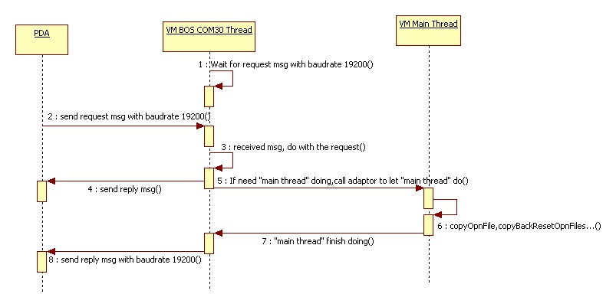

BOS error code define
EVA error code | Event description | Definition | Is Fatal | Remarks
ECM | Flash error | Read file error. | Yes | eBosErrRead
ECM | Flash error | Write file error. | Yes | eBosErrWrite
ECM | Flash error | Create file error. | Yes | eBosErrCreate
ECM | Flash error | Open file error. | Yes | eBosErrOpen
ECM | Flash error | Rename file error. | Yes | eBosErrRename
ECM | Flash error | Delete file error. | Yes | eBosErrDelete
ECM | Flash error | Copy file error. | Yes | eBosErrCopy
OA_200 | Short of “machine.dat” file | It must have “machine.dat” in BOS. | Yes | eBosErrMachineDat

EVA

EVA Database Detail Design
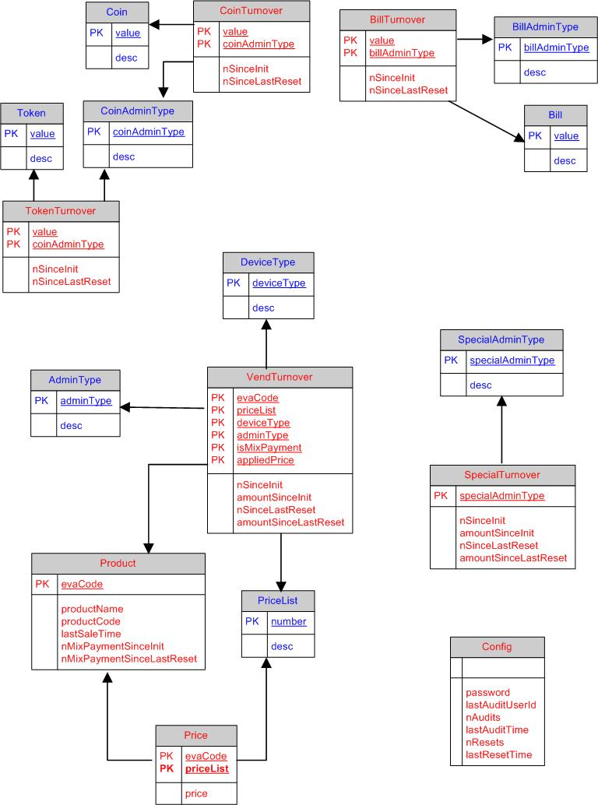

EVA Class Diagram
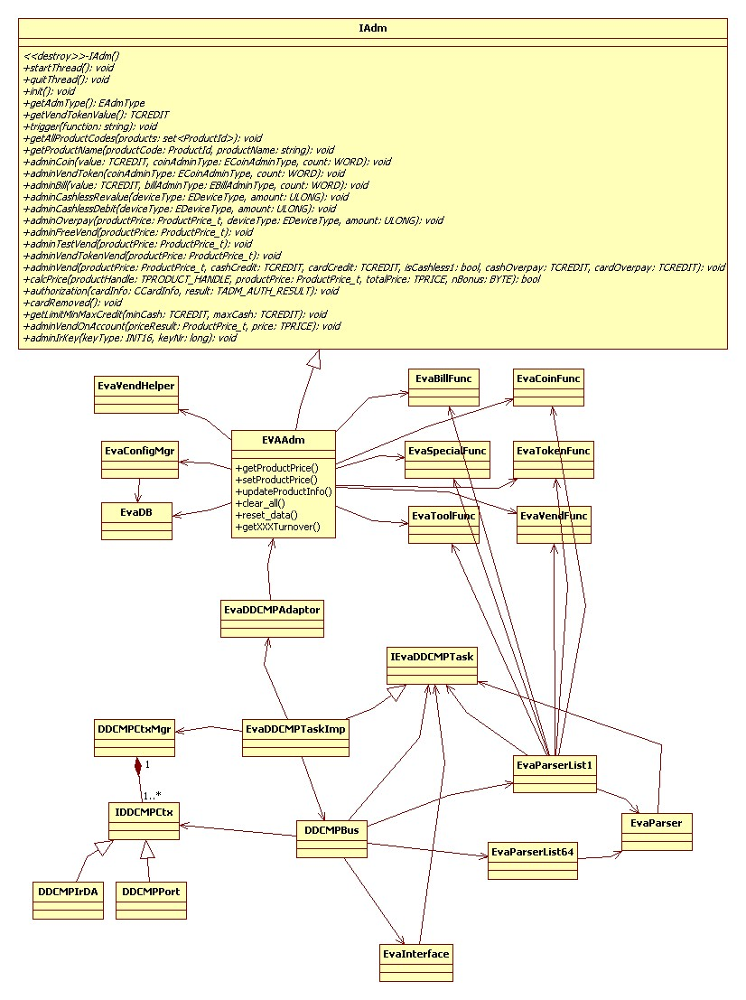

Class Introduction

EVAAdm
The IAdm interfaces implemented in EVA, adding some EVA specific interface and implement.

Unit test: testEVA project in testEVA solution.
In test_eva.h
void testEvaAdm();//test class EVAAdm

EvaVendHelper
It is EVAAdm’s friend class. The work which adminVend() in EVAAdm will implement in this class.

Unit test: testEVA project in testEVA solution.
In testEVAAdm.h
void test_evaVendHelper_adminVend(EVAAdm *pEVAAdm); //test EvaVendHelper

EvaDB
Database tables: Product, Price, VendTurnover, CoinTurnver, BillTurnover, TokenTurnover, Config read/write interface, implemented by SQLite database.

Unit test: testEVA project in testEVA solution.
In test_eva.h
void testDB(); //test class EvaDB

EvaConfigMgr
Database table: "Config read/write interface.

Unit test: testEVA project in testEVA solution.
In testDB.h
void testEvaConfigMgr();

EvaToolFunc, EvaVendFunc, EvaCoinFunc, EvaBillFunc, EvaSpecialFunc, EvaTokenFunc
EVA turnover statistics function. All will be “static public” function, and can be called by “main thread” and “DDCMP child thread”.

Unit test: testEVA project in testEVA solution.
In testBillFunc.h, testCoinFunc.h, testTokenFunc.h, testSpecialFunc.h testVendFunc.h;

EVA DDCMP slaver

Thread design
Just like as BOS thread design, EVAAdm will be running in “main thread”.
EVA DDCMP Slaver will be running in “DDCMP child thread”.
The “main thread” and “child thread” interface will be defined and implemented in EvaDDCMPAdaptor.
“DDCMP child thread” will clone a copy of DB memory from “main thread”.
“Main thread” or “child thread” will access DB memory from it holds.

DDCMP Class Introduction

EvaDDCMPAdaptor
Define “main thread” and “DDCMP child thread” interfaces and implements.

DDCMPCtxMgr,IDDCMPCtx,DDCMPPort,DDCMPIrDA
Define DDCMP communication context.
Now it has COM Port and IrDA. In the future Bluetooth will be added.

DDCMPBus
Do DDCMP process.

Unit test: testEVA project in testEVA solution.
In test_eva.cpp
static void testDDCMPBus(); //test class DDCMPBus

EvaDDCMPTaskImp
Implement EVA DDCMP child thread body.

EvaInterface
Used by DDCMPBus. While doing ddcmp process, doing some work, such as:
check password, reset/non_reset data, modify price table when receiving list64 file, get/set DB memory...

EvaParser
Parsing list1/list2 or list64 file.

Unit test: testEVA project in testEVA solution.
In testEvaParser.h
void testEVAParser_parseLineString(); //test class EvaParser

EvaParserList1
Parsing list1 or list2 file.

Unit test: testEVA project in testEVA solution.
In testEvaParser.h
void testEVAParserList1_getLineString(); //test class EvaParserList1
void testEVAParserList1_expandFile();//test class EvaParserList1
void testEVAParserList1_parserFile();//test class EvaParserList1

EvaParserList64
Parsing list64 file.

Unit test: testEVA project in testEVA solution.
In testEvaParser.h
void testEVAParserList64(); //test class EvaParserList64

Unit Test
(1). testDDCMP project in testEVA solution.
“Main thread” and “DDCMP child thread” testing DDCMP protocol and process.

DDCMP Thread Model
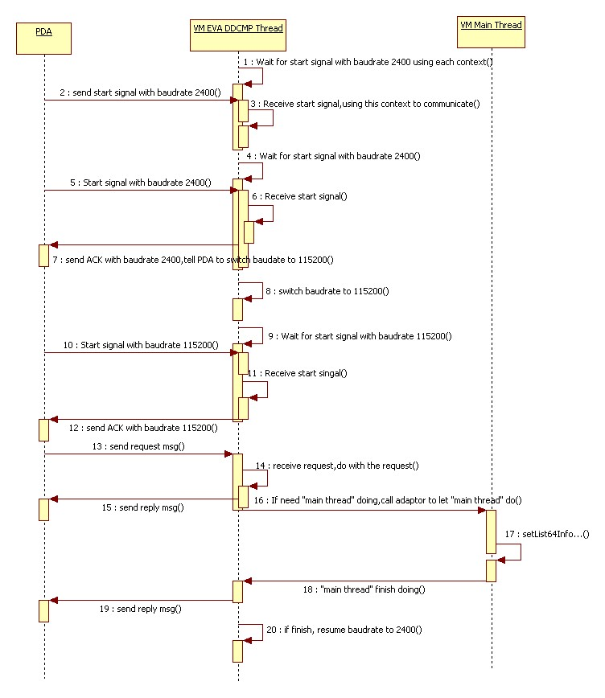

EVA error code define
EVA error code | Event description | Definition | Is Fatal | Remarks
ECM | Flash error | Read db file error | Yes | eEvaErrRead
ECM | Flash error | Write db file error | Yes | eEvaWrite

